Puffball Zinger
You will need:
- One plastic cup
- A pair of scissors
- One balloon
- One puffball
Instructions:
- Use your scissors to cut the bottom off of your cup.
- Recycle the bottom part of the cup. Keep the top part.

- Tie a knot in the end of the balloon.

- Cut the balloon at the widest part (you’ll be cutting off about ½”).
- Throw the smaller part (the part without the knot in it) of the balloon in the trash can.

- Stretch the opening of the balloon (the cut side) over the lip of the cup (the lip is the edge that you would usually drink from).

- Turn your zinger so that the balloon faces toward the ground. Place a puffball inside the zinger, pull gently on the end of the balloon, and let it go.
Project idea and photos: http://www.cometogetherkids.com/2011/09/mini-marshmallow-shooters-or-pom-pom.html

Mini Catapult

You Will Need:
- One clothespin | - Glue (shared, at tables)
- One small paper cup | - One popsicle stick
- Two wooden cubes | - Three rubber bands
- One flat wooden base

- Set your base on the table, and set your clothespin on top of it. Add three rubber bands. Your project should look like this:
- Lift up the clothespin and add a block under each end.

- Put a little bit of glue between each block and the base.
- Put a little bit of glue between each block and the clothespin.
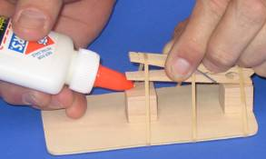
- Attach the popsicle stick to the upper edge of the wider side of the clothespin, using a little bit of glue. 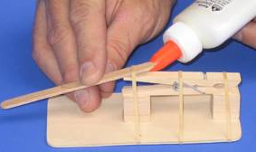
- Use a little bit of glue to attach the small paper cup to the end of the popsicle stick. Be sure to leave a little bit of popsicle stick exposed beyond the cup!
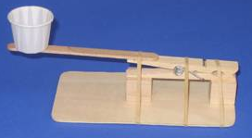
- Wipe up any glue that may have dripped on the table, and close the glue bottle.
- Take your catapult home, let it dry for one full day, remove the rubber bands, and give it a try!
See what happens when you try zinging with the base flat on a table, when you tilt your catapult, and when you try zinging different items. How can you get the maximum height? How about maximum distance? Project idea and photos: http://www.sci-experiments.com/catapult/catapult.html

