Balloon Car
You will need:
1 balloon
2 straws
1 wooden craft stick
2 mints
Duct tape (shared, at tables)
Scissors
Helpful hint: before you begin, blow up your balloon a few times to stretch it a little.
- Notice that your straws each have a long side and a short side, thanks to the bendy section. Put the short end of one of the straws into the balloon.

- Use a piece of duct tape to attach your balloon to the straw so that no air can escape. Attach it above the bendy part, so your straw can still bend freely. Make sure to attach it tightly! Congratulations! You have just created a jet!

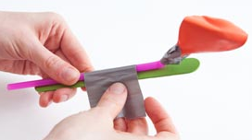
- Tape your jet to the craft stick, like this, to create the body of the car:

- Unwrap the two mints. Throw the wrappers in the trash can.

- Fold the short part of your unused straw all the way over to meet the long part. Tape it in place.
- Slide the two mints onto the long part of the straw.
- Being sure to leave enough space for the two mints and the craft stick (plus a little bit extra), fold the other end of the straw over and tape it in place. You might need to trim a little bit of the straw off. Congratulations! You have just made an axle!

- Attach the axle to the body of the car using duct tape. Place the axle on the same end of the body as the balloon.
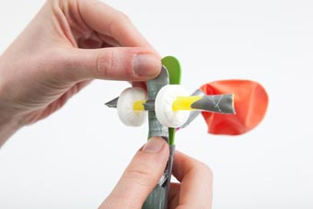
- Blow up the balloon through the straw. Place it on a flat surface and let your car go!
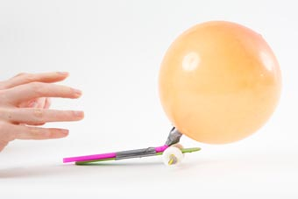

How far can your car go?
What happens if you move the axle to the other end of the car?
Project idea and photos: http://pbskids.org/designsquad/build/2-wheel-balloon-car/

